ADA Website Help
Vic Van Horn
10 December 2018
Proposal to create ADA Help, remediation request, and feedback submission process and tracker.

The process will be broken into 3 parts.
- Department User Preparation
  - Each website outside the State of Nevada CMS will need to setup their site with links provided.
  - Website within the State CMS will not need to do anything; the web team will update their site for them with an internal automated process.
- ADA Users submit a request for assistance
  - There will be several links on each webpage that will assist ADA users in requesting help, document remediation, or providing feedback.
- System notification and tracking the ADA submission
  - The ADA Help system will assist departments in receiving, and tracking user issues and feedback.

Department User Preparation
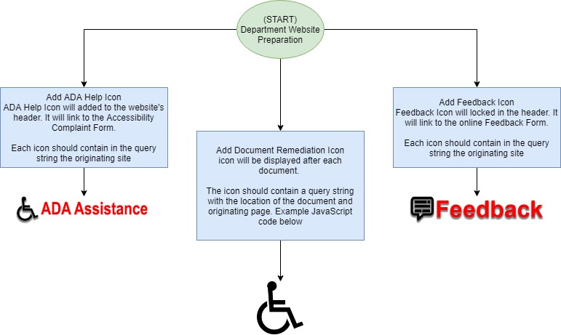

Users within the State of Nevada CMS will automatically receive the 3 items and will not have to do anything to prepare.
Users outside the State of Nevada CMS will need to add 2 buttons, “ADA Help” and “Feedback” with relevant links. They will also need to add links to each document for remediation assistance. To get a copy of the link’s query string format and JavaScript example document modifier please contact Linda DeSantis, manager of the web team.

ADA Help
ADA Users submit a request for assistance

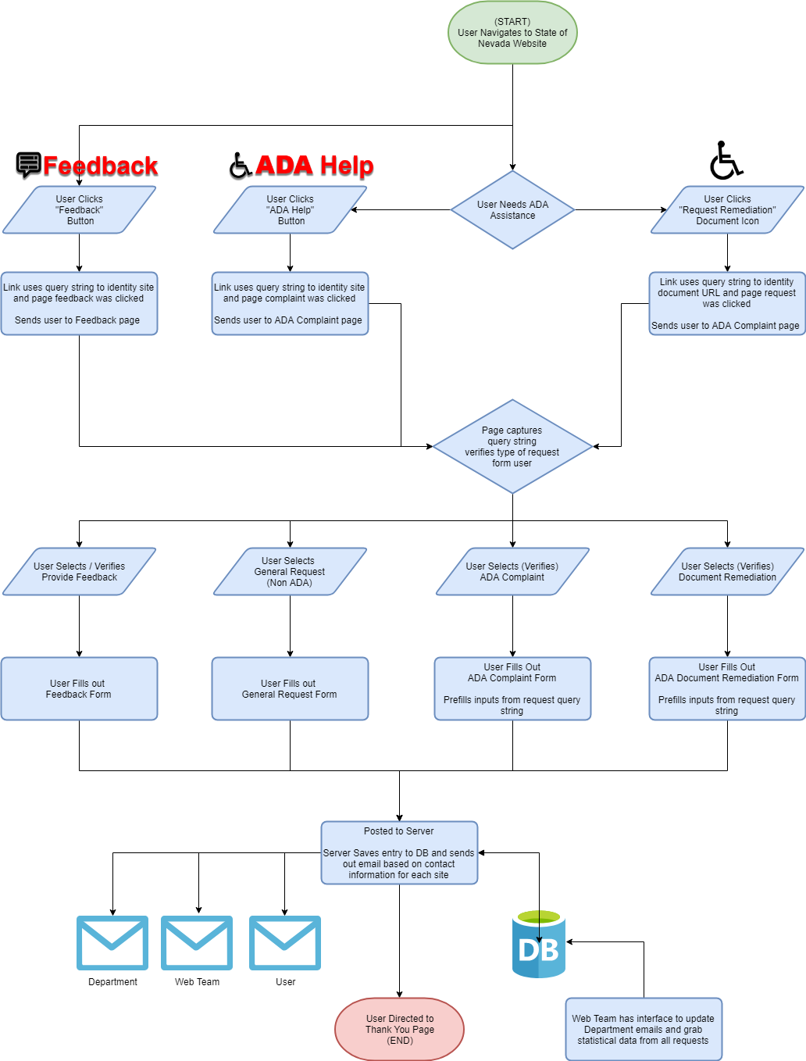
Users will be provided with links that will direct them to a State of Nevada ADA Help page. Part of the form will be prefilled using query strings from the originating sender to assist the user. Users will need to fill out the remaining fields on the online form that include their email and comments. Once they submit it the system will send out 3 emails. One to the department contacts, one to the web admin group, and one to thank and notify the user that their request has been submitted.
More on the how the server handles the request below.

ADA Reporting
System notification and tracking the ADA submission

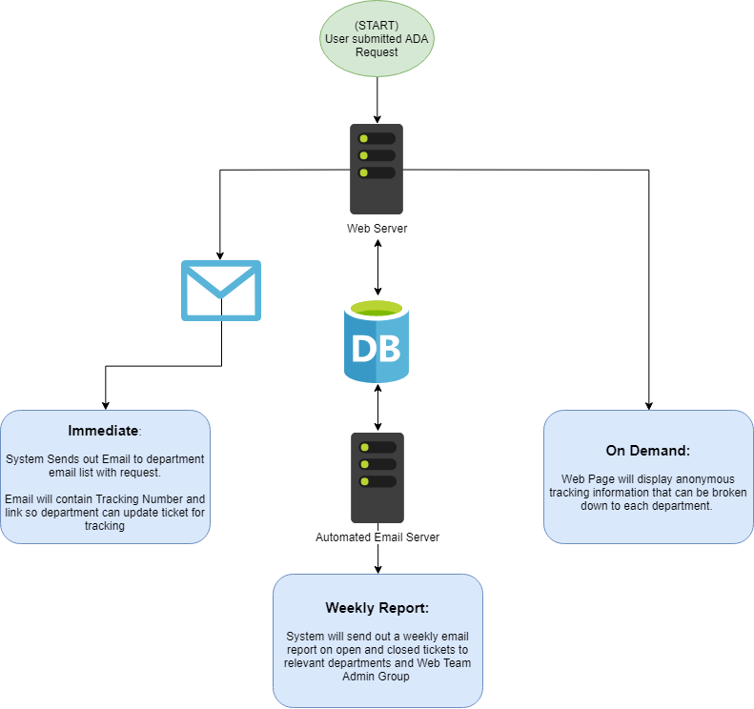
When a user submits a request, the immediate actions is the email notification system sends emails to the relevant users and that data is stored in the database for future tracking. In the department’s email there will be a link with keyed query string that will allow the department representative to update the status of that request.
There will also be a weekly status update email with all tickets that were closed that week and any open issues. That email will be sent to the department contacts for their department, and a roll up will be sent to the web admin group.
Departments will also be able to view an on-demand report online. They’ll be able to pull up their department’s closed tickets, and any open issues.

