ADA Assistance
Write up for http://adahelp.nv.gov

14 Feb 2019
Victor Van Horn

Table of Contents
ADA Assistance 1
System Overview 3
User Flows 4
System Flow Chart 4
The End User Flow (General Public) 5
State of Nevada Department PIOs and Administrators Flow 6
Setting the Department Contacts 9
Reporting Features 11
Example Emails for Admin group and Department 12
Example Email Submitter would receive 14
Weekly Administrator’s Report 16

System Overview
The ADA Assistance website (http://adahelp.nv.gov) is a website designed to all people in the State of Nevada, and those that use State of Nevada websites to request ADA assistance. There are five different forms to try to address the different types of requests.
- ADA Digital Complaint Form
  - This is used to address ADA shortcoming in websites, digital documents, and text telephone (TTY)
- Physical Complaint
  - This form is for those with physical complaints. It covers items like cognitive access, physical access like wheel chair ramps.
- ADA Document Remediation
  - This form is for digital documents like PDF, Word, and Excel to be remediated so those that use screen reader technology can have it read to them.
- Request for Information
  - This form is for those that want someone from a specific department to contact them.
- Feedback
  - This form is used to provide feedback about a specific department.
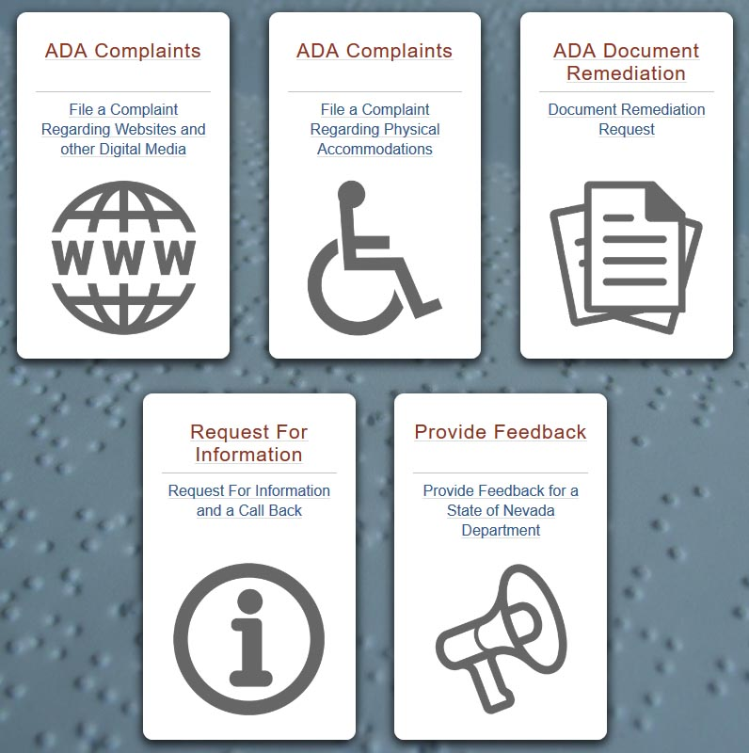

User Flows

System Flow Chart
Flow chart of end user ticket submission explained below.

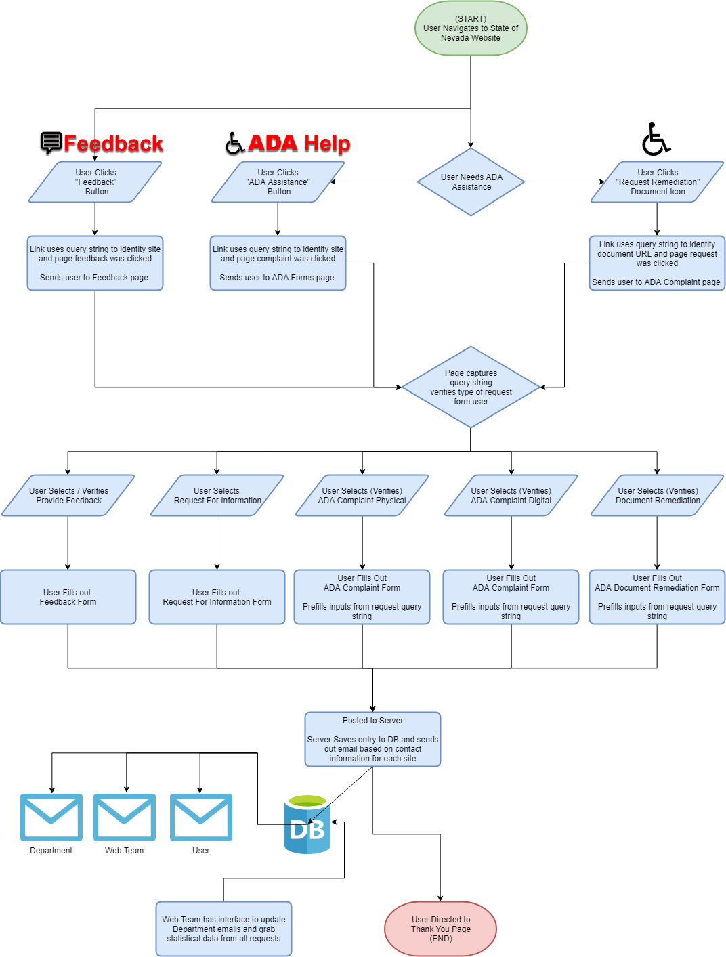

The End User Flow (General Public)
- The links on all Ektron websites to adahelp.nv.gov use a query string, so when the ADA Assistance, Feedback, or Document Remediation links are clicked the ADA Assistance website can identify the user’s originating site. This is used to pre-fill out the department to more accurately notify the department contact.
- There are 3 different types of links in the State of Nevada Ektron system. 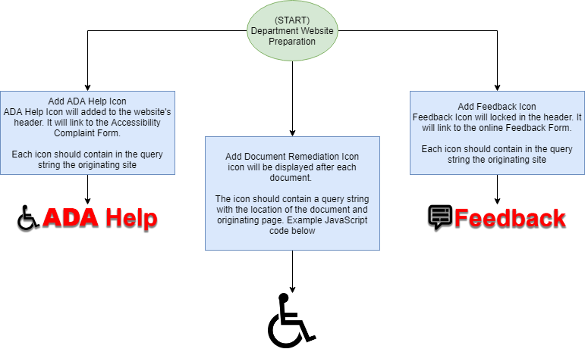
  - In the header there’s a feedback link that takes the user directly to the feedback form
  - In the header there’s an ADA Assistance link that takes the user to the ADA Assistance main page where they can select any of the 5 different forms
  - The final link type, document remediation, is added to the end of every document in the Ektron site. That link tracks not only the originating site, but the document that needs remediation. That link takes the user directly to the document remediation form.
- When the user fills out the form each form has several common inputs. Those inputs are:
  - First and Last name
  - Email Address
  - Phone Number (Optional)
  - Which department they are submitting to. The exception is the Physical Accommodations form which is sent directly to the EEO Officer.
  - If the user would like to assist with Nevada’s ADA remediation efforts
  - Rate this process
- Once the form is completed and all required fields are filled several things occur
  - The form is saved to the database, so State of Nevada Employees can view at any time
  - Emails are added to the database email queue for the following:
    - The requester that submitted the form
    - The department contacts with a login in link
    - The webteam with a login link. The webteam receives a copy of every request
- The user is then directed to a thank you page, so they may review their submission

State of Nevada Department PIOs and Administrators Flow
The PIOs and administrators begin their process after a user has submitted their ticket.
- Once the end user submits a ticket the department PIOs and administrators will receive a ticket in their email with that ticket’s details, who submitted the ticket, and a link to the ticket manager on the ADA Assistance website.
- To manage the ticket the Department PIO just needs to click the link and they will go to the ticket manager page that will show them all their department’s tickets. You can also search or filter the ticket list.
- The Department PIO will then click the relevant ticket to view the ticket, modify the ticket status, or add comments.
- Once the Department PIO has completed the ticket they can visit the site, open the ticket, and close it.

View of the ticket manager
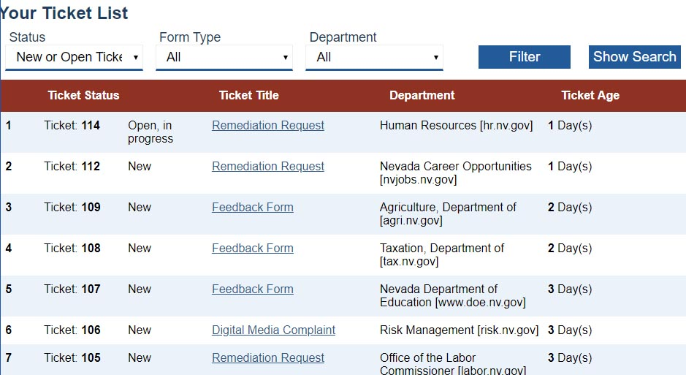

View of the department ticket tracker update page
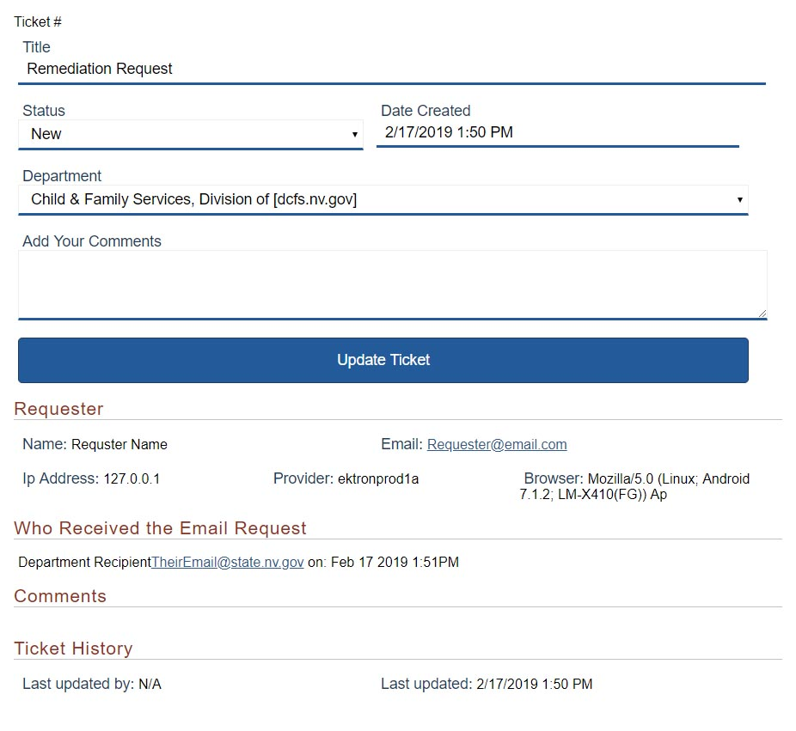

View of the copy of the form the user submitted. This is available next to the ticket tracker update page
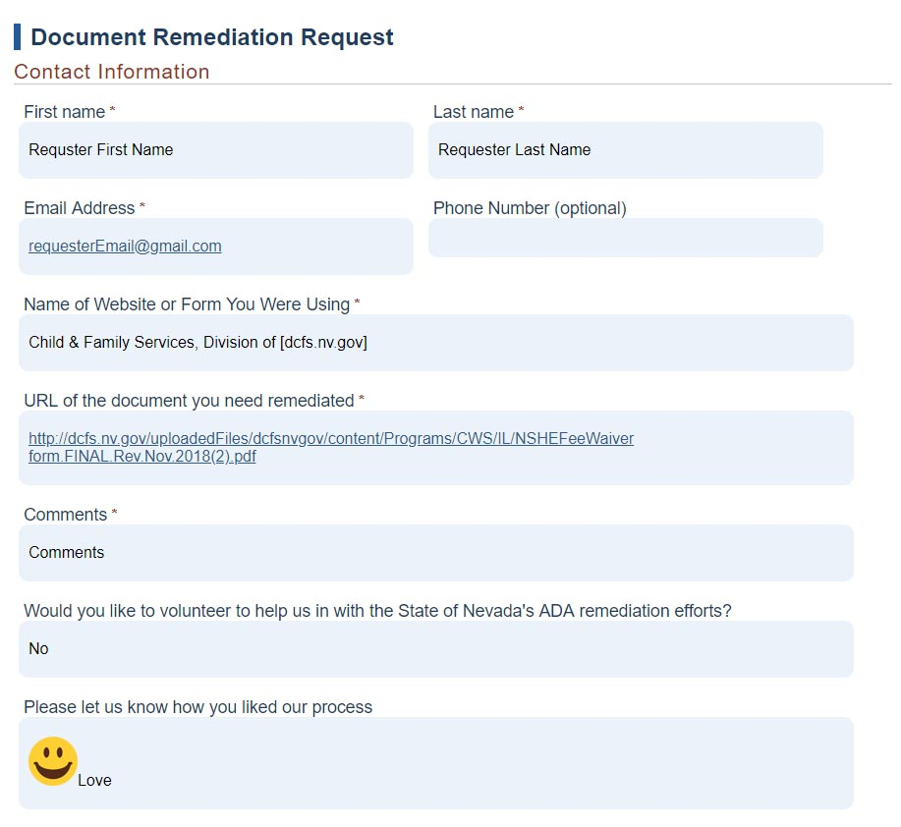

Setting the Department Contacts
On HAL http://hal.nv.gov/html/adahelp/userList.aspx the webteam can manager and set users for each department. They can also set who receives the submitted emails, who receives weekly reports, and which employee contact will appear on the Requester’s email.

View Users by division
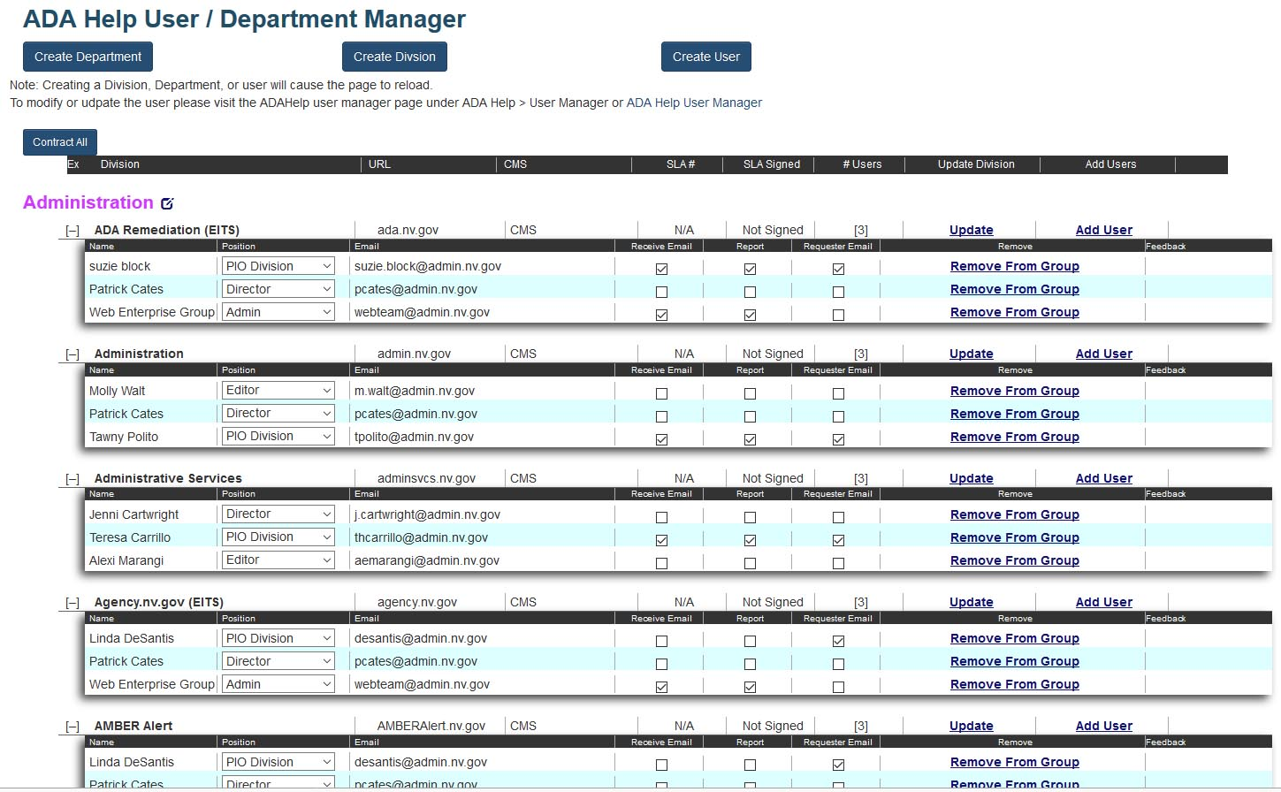
View Divisions by User (Reverse lookup)
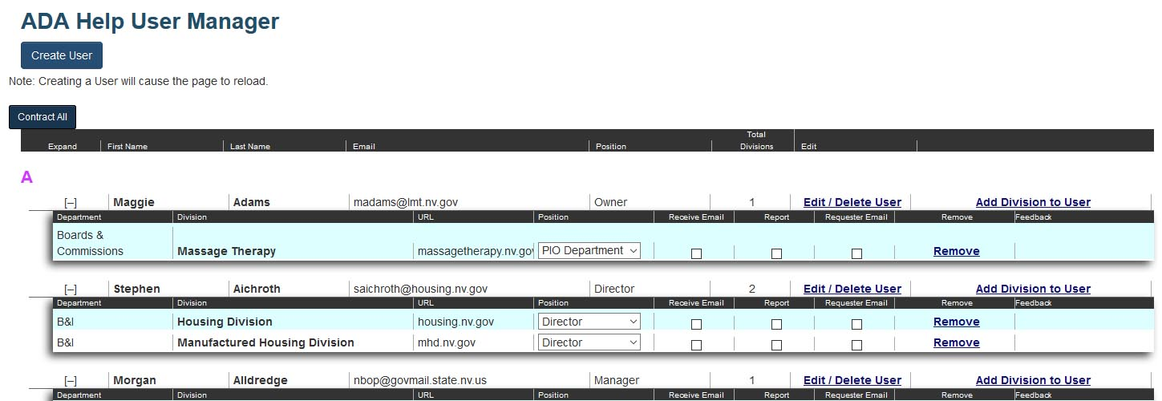
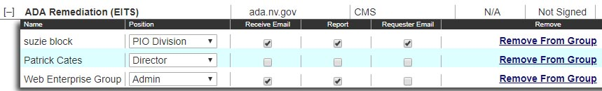
Each division can have people assigned to that division. They should be State of Nevada Employee. There are no limitations on the number of employees.
Each employee assigned to a department receives a role of Director, PIO Department, PIO Division, Editor, Manager, or Owner. Other Position Names can be added without effecting the program.

Along with assigning each employee a position there’s 3 different flags. When the first flag “Receive Email” is set to true that employee will receive help tickets as soon as they are submitted.
When the second flag “Report” is set to true that user will receive weekly reports of the status of their tickets. (This section still needs to be completed)
When the last flag “Requester Email” is set to true that employee’s name and email will appear on the requester’s email to let the requester know who received it, and if they have additional questions, they have that employee’s email to directly contact.
Any position can have the flags set, but generally the Division PIO will receive the requester’s tickets and be placed on their email.

Each department has a SLA entry for future reporting. The reason for that fields is that EITS is providing Siteimprove software and ALL agencies must sign a Service Level Agreement (SLA) before EITS web team releases the license to the department/divisions/boards.

Reporting Features
Since all data is saved in a database reports can easily be created. Below are the three different types of ticketing reporting.
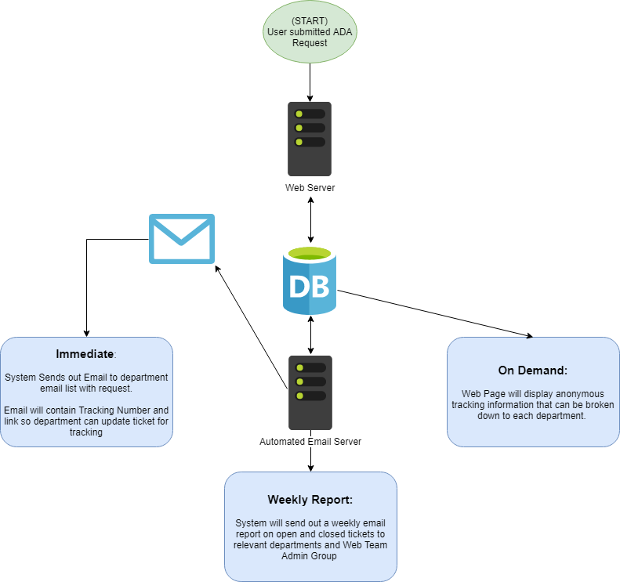
- The first is the user ticket submission report. This is automatically sent with ticket details and login link any time a user submits a ticket. The user’s flagged to receive these in the department and the webteam receive these reports
- The Second is the weekly summary report. It currently runs each Friday at 5:00 AM but can run any day of the week. This report grabs all the tickets in the system, summarized the data and send the report to all set to receive it based on their department.
- The third type of report is an on-demand report located http://hal.nv.gov/html/adahelp/reports.aspx. This is currently in the process of being built, but it can grab the live data and create any type of report the user needs.

Example Emails for Admin group and Department
Vic Van Horn,
An ADA Ticket, Remediation Request, has been submitted for your department.
Submitter's Name: Submitter’s Name
Submitter's Email: submittersEmail@gmail.com
On Date: 2/17/2019 1:50 PM

Ticket Number: #
To Update this ticket: http://adahelp.nv.gov/uniqueUpdateLink
Link will expire on: 2/24/2019 1:50 PM

Remediation Request Ticket #:
First Name  First name | Last Name  Last name
Email  sumbmittersEmail@gmail.com | Phone Number  7022349166
Name of Website or Form You Were Using
Child & Family Services, Division of [dcfs.nv.gov]
URL of the document you need remediated
http://linkToDocument.com
URL of the webpage the document was found
http://linkToWebpageThatHasTheDocument.com
Comments
User’s Comment.
Would you like to volunteer to help us in with the State of Nevada's ADA remediation efforts?
Yes
Please let us know how you liked our process
Love this process.
Ticket has been sent to: List of department personnel that received this ticket
Note: if you have received this ticket and to know why you received this ticket, please send an email to stateweb@admin.nv.gov

Example Email Submitter would receive
Thank you for submitting a request to the State of Nevada. Below is a copy of your submitted ticket as well as a ticket number for your reference.
Digital Media Complaint Ticket #:111
First Name  Submitter’s first name | Last Name  Submitter’s Last name
Email  submittersEmail@gmail.com | Phone Number
Name of Website or Form You Were Using
Test Ticket [testtest.nv.gov]
URL of the page you are working on
http://webpage
Please explain in detail the issues and barriers you have encountered.
Submitter’s comment
Were you able to accomplish what you needed?
Not Answered
What devices are you using?
Mobile Device,
What is your skill level?
Beginner
Would you like to volunteer to help us in with the State of Nevada's ADA remediation efforts?
Yes
Please let us know how you liked our process
Love this process

Your ticket has been forwarded to: Department Name and Email contacts for the agency: Test Ticket

In the case above there are department names and email addresses. If there aren’t any listed contacts for a department it simply leaves that line out and lets the user know which department it was sent to.

Weekly Administrator’s Report
Below is an example of the weekly administrator’s report that is automatically emailed each Friday. The report has a wrap up of the number of tickets by form and a detailed list of all tickets currently in the system.
